You have booked an electrical connection at (please highlight event):
- Malton Traditional Weekly Market
- Malton Monthly Market
- Spring Food Lovers Festival
- Meadowfest
- Malton 10k
- Harvest Festival
- Christmas Festival

To help our electrician balance the power supplies please list in the table below the equipment you are plugging in. Please also indicate the type of connection (13amp domestic, 16amp commando or 32amp commando) and the total wattage of the appliance (this information can usually be found on a plate or sticker next to the power cord). Please remember that your equipment should be PAT tested and the relevant certificates available for inspection upon request.

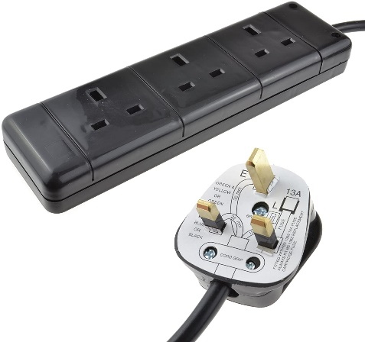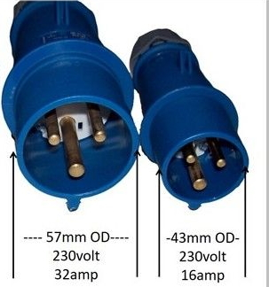

Business Name | Pitch size required (width x depth) inc hitches, awnings, steps, etc
Lottie Loves | 5m x 3m

Electrical item | 13amp (domestic) | 16amp (commando) | 32amp (commando) | Wattage
Small Household fridge |  |  |  | 192
2 Soup Kettles (400 each) |  |  |  | 800
Ipad Charger, not used all the time
Hot Plate, only used in small intervals to heat more product |  |  |  | 1500

