RISK ASSESSMENT FORM

|  |  |  |  |
| --- | --- | --- | --- |
| Company Name: | O’Donnell Moonshine | Emergency Contact: | Matthew Webster |
| Site: | Malton Town Centre, Malton, North Yorkshire, YO17 7LX | Emergency Contact Phone: | 07903169877 |
| Event: | Malton Food Lovers Festival – Spring 2025 | Date from/until: | 24/05/2025 to 26/05/2025 |

|  |  |  |
| --- | --- | --- |
| **Hazards involved with activity** | **Safety measures you will put in place to reduce the risk of**  **Accidents** | Rating band  Severity of Risk  1 2 3 4 5  1 Low Severity  5 High Severity |
| **Setting up and dismantling stalls.** | Ensure all poles, stall sections, tables and crates etc are placed in a tidy  manner and do not create trip hazards to persons walking past. Take particular care in the winter when both activities could take place before sunrise/after dark and in icy  conditions. | 3 |
| **Vehicle Movement during set-up &** **Break Down.** | Be especially vigilant for pedestrians, use a banks man if necessary Take particular care in the winter when both activities could take place before sunrise/after dark and in icy conditions | 3 |
| **Slips/falls/trip hazards.** | Regularly ensure floor area and walkways are clear of debris from the stall  e.g. produce or bags. Remove all rubbish from around the site Remove any potential slip or trip hazards; ensure any trip hazards that cannot be  moved are clearly marked with hazard tape | 2 |
| **Trip Hazard Promotional Banners.** | Ensure Banners are placed so as not to cause trip hazards, to be weighted  down where necessary to avoid falling over. | 1 |
| **Vehicles** | Remove all vehicles from the area during trading. | 1 |
| **First Aid** | Make sure you have provided First Aid Equipment and that it is up to  date, a mobile phone must be carried to call the emergency services. | 1 |
| **Re-Stocking** . | Ensure restocking is done outside of trading hours whenever possible. If this isn’t possible insure stock is well tied to trolley, looking out for members of the public and not using vehicles within the operational area | 1 |
| **Power Tools (Ins * De-Ins)** | Ensure that staff is correctly trained in the use of power tools (Drill). | 3 |
| **De-Installation** | Ensure trading area is completely clear of all hazardous waste and debris. | 1 |
| **The sale of alcohol**   * **Challenge 25** * **Proxy sales** * **Consumption off site** | * Always ensure to ask for either a passport or driving license and check any prospective sampler or purchaser they are above the age of 18 if they look below the age of 25 **(Challenge 25 Policy).** * Display Challenge 25 sticker. * Ensure nobody is buying on behalf of anyone underage **(Proxy sales)** * Don’t sell or allow samples to anyone under the age of 18. * Ensure bags are taped up when given to customers so that they do not open the sealed bottles on the premises and explain the product is for consumption off site. * Display a sign that reads **“for consumption off site”.** | 3 |

Signature: 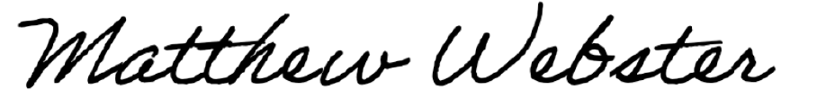

Print name: Matthew Webster Date: 14/04/2025