You have booked an electrical connection at (please highlight event):
- Malton Monthly
- Market/Spring Food Lovers Festival
- Meadowfest
- Summer Food Lovers Festival
- Marathon Du Malton
- Christmas Festival

To help our electrician balance the power supplies please list in the table below the equipment you are plugging in. Please also indicate the type of connection (13amp domestic, 16amp commando or 32amp commando) and the total wattage of the appliance (this information can usually be found on a plate or sticker next to the power cord). Please remember that your equipment should be PAT tested and the relevant certificates available for inspection upon request.

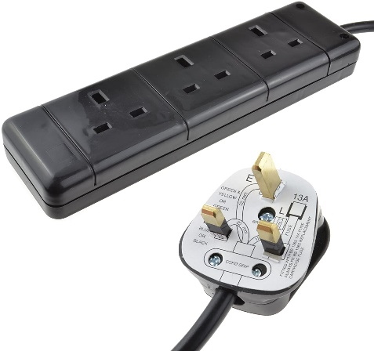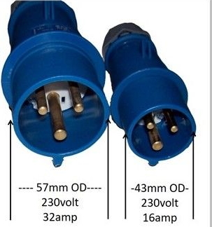

Business Name | Pitch (for office use)

Electrical item | 13amp (domestic) | 16amp (commando) | 32amp (commando) | Wattage

