Yorkshire Wildlife Christmas Fair Information

Wooden Chalets

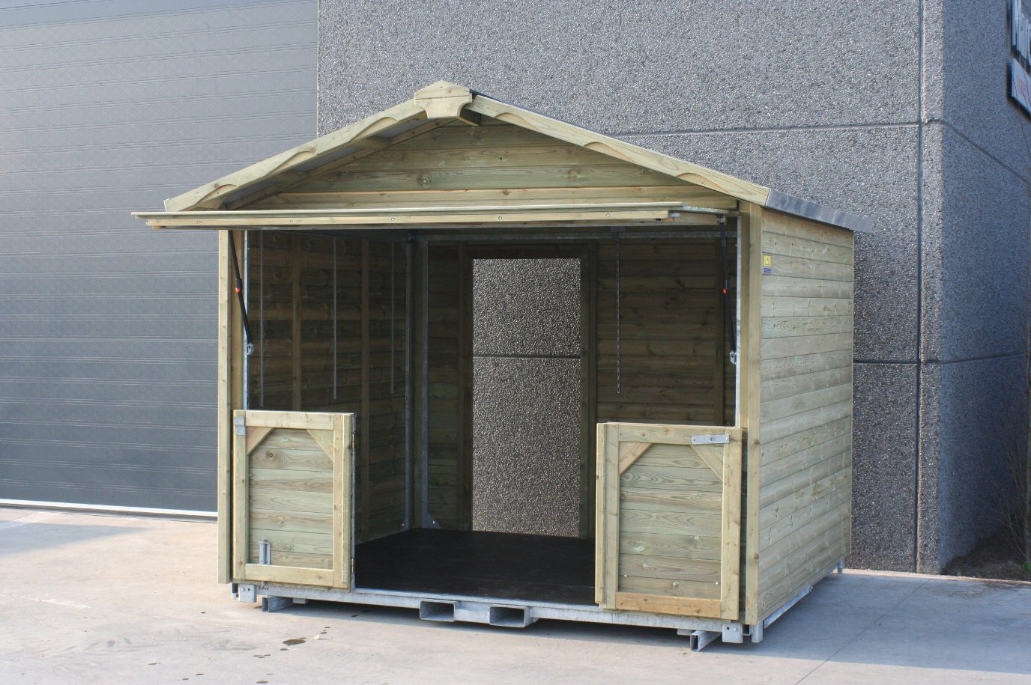

The Barn Door Chalet is our most flexible option. The doors can be kept open for when you need walk in room or closed and used in the same way as our Counter Type Chalet.

The doors allow for equipment to be brought easily into the chalet, whilst being fully lockable and secure when closed up.

The Chalet comes equipped with Lighting.

You will need to bring your own tables to set up the Chalet – these are not supplied.

**Dimensions**

* Frontage: 2.98m
* Depth: 2.51m
* Height: 2.76m

**Trader Car Parking**

The Car Park is located a few meters away from the Christmas Fair – Please note the YWP will not supply trollies so you will need to bring your own to get your stock from your vehicle to your Chalet.

**Trading Hours**

Your Chalet must be manned between the hours of 12.00 and 20.30 as we have Winter Illuminations on within Yorkshire Wildlife park you will receive higher footfall from 15.00– 20.00 We do have the Grotto that is located at the start of the Christmas Fair this is open from 10.30.

Access to cabins will be from 9.00am if you would like to set anything up the day before please contact the event manager to arrange this.