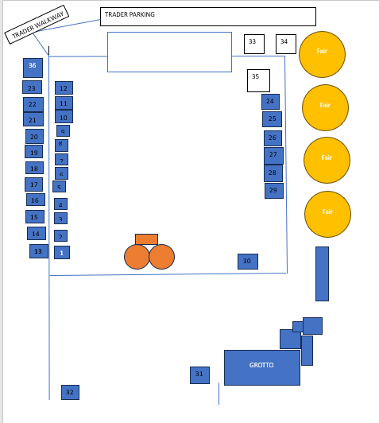

Stall |  | Number
Nom Bakes | blondies Brownies | 1
coffee and Mulled Wine |  | 2
Dogs trust | memberships | 3
CJ accessories |  | 4
Sadhana Spririt | Products from Nepal | 5
Yorkshire candle company | candles and melts | 6
Rotari Cakes | Cakes | 7
Maple Tweed |  | 8
Stall |  | Number
LUNIQUE DESIGNS |  | 9
Guide Dogs |  | 10
minifigure mania | mini figures | 11
Charlie Jane | Wooden Gifts | 12
Oh So Pretty | Tablewear | 13
RSPB |  | 14
magnetic accessories | wellness | 15
Childrens Hospital Charity |  | 16
Vanilla Bean | brownies and cookies | 17
 |  | 18
Molly Belle Home boutique | Home accessories | 19
Pesvebi ltd | Vodka and Gin | 20
Crafty Lil | Julie Lauder | 21
D&H bakes | cakes | 22
BY THE MIX | COCKTAILS | 23
KERR CRAFTS |  | 24
KA PHOTGRAPHY |  | 25
Candy Creations | Sweets | 26
Candy Creations | Sweets | 27
Make Harrogate | Jewellery | 28
coffee and Mulled Wine |  | 29
YWP Santa Shop |  | 30
Grotto Hot Chocolate |  | 31
ENTRY CABIN |  | 32

Swing Grill | 34
Toppings Pies | 36

